Case Study Report



**Tech Saksham**

Data Analytics with Power BI

“**360-degree business analysis of online delivery apps using power bi**”

**“SRI PARAMAKALYANI COLLEGE”**

|  |  |
| --- | --- |
| **NM ID** | **NAME** |
| A51B983A6004CE6A82C4775AF3128C46 | MUPPUDATHI M |

|  |  |
| --- | --- |
|  |  |
|  | **Trainer Name:** UMAMAHESWARI |
|  | **Master Trainer:** UMAMAHESWARI |

**ABSTRACT**

In the competitive landscape of food delivery services, operational efficiency is paramount for success. Zomato, a leading global platform for food delivery and restaurant discovery, recognizes the significance of optimizing its delivery operations to meet customer expectations and maintain a competitive edge. This abstract presents a case study on the implementation and impact of the 360 Delivery initiative on Zomato, leveraging the analytical capabilities of Microsoft's Power BI.

The 360 Delivery strategy encompasses a holistic approach to enhance various facets of the delivery process, including logistics, route optimization, delivery time estimation, and customer experience management. Leveraging Power BI, Zomato integrates data from diverse sources such as order history, delivery routes, customer feedback, and real-time traffic updates to derive actionable insights.

This case study explores how Zomato utilizes Power BI's robust analytical features to gain deeper visibility into its delivery operations. Through interactive dashboards and data visualization tools, Zomato's management gains real-time insights into key performance metrics such as delivery times, driver efficiency, order volumes, and customer satisfaction scores. These insights enable data-driven decision-making, allowing Zomato to identify bottlenecks, optimize routes, allocate resources efficiently, and improve overall delivery performance.

**INDEX**

|  |  |  |
| --- | --- | --- |
| **Sr. No.** | **Table of Contents** | **Page No.** |
| 1 | Chapter 1: Introduction | 4 |
| 2 | Chapter 2: Services and Tools Required | 6 |
| 3 | Chapter 3: Project Architecture | 7 |
| 4 | Chapter 4: Modeling and Result | 9 |
| 5 | Conclusion | 18 |
| 6 | Future Scope | 19 |
| 7 | References | 20 |
| 8 | Links | 21 |

**CHAPTER 1**

**INTRODUCTION**

* 1. **Problem Statement**

Zomato, a prominent player in the food delivery industry, faces the challenge of optimizing its delivery operations to meet the ever-growing demands of customers while maintaining cost-effectiveness and efficiency. Despite having a vast network of delivery partners and a robust technological infrastructure, Zomato encounters various operational hurdles such as unpredictable traffic conditions, inefficient routing, fluctuating order volumes, and inconsistent delivery times.

These challenges pose a significant risk to Zomato's competitiveness and customer satisfaction levels. Without an effective mechanism to streamline its delivery processes, Zomato risks losing customers to competitors who can offer faster and more reliable delivery services. Additionally, inefficient delivery operations result in increased operational costs, reduced profitability, and potential reputational damage.

Although Zomato collects vast amounts of data from various sources, including order histories, delivery routes, and customer feedback, the company lacks a cohesive analytics solution to extract actionable insights and optimize its delivery operations effectively. Existing reporting systems fail to provide real-time visibility into key performance metrics, hindering proactive decision-making and preventing Zomato from addressing operational inefficiencies promptly.

Thus, the problem statement revolves around the need for a comprehensive analytics solution that leverages Zomato's rich data assets to enhance its delivery operations. This solution should enable Zomato to analyze delivery performance metrics, identify bottlenecks, optimize delivery routes, forecast demand patterns, and improve overall operational efficiency.

* 1. **Proposed Solution**

The proposed solution is to develop a PowerBI dashboard that can analyze and visualize real-time customer data. The dashboard will integrate data from various sources such as transaction history, customer feedback, and demographic data. It will provide a comprehensive view of customer behavior, preferences, and trends, enabling banks to make informed decisions. The dashboard will be interactive, user-friendly, and customizable, allowing banks to tailor it to their specific needs. The real-time analysis capability of the dashboard will enable banks to respond promptly to changes in customer behavior or preferences, identify opportunities for cross-selling and up-selling, and tailor their products and services to meet customer needs.

* 1. **Feature**
* **Real-Time Analysis**: The dashboard will provide real-time analysis of customer data.
* **Customer Segmentation**: It will segment customers based on various parameters like online delivery option, table booking options, rating, etc.
* **Trend Analysis**: The dashboard will identify and display trends in customer behavior.
* **Predictive Analysis**: It will use historical data to predict future customer behavior.
  1. **Advantages**
* **Data-Driven Decisions**: Zomato can make informed decisions based on real-time data analysis.
* **Improved Customer Engagement**: Understanding customer behavior and trends can help Zomatos engage with their customers more effectively.
  1. **Scope**

**Food Delivery:** Zomato started as a restaurant search and discovery platform but quickly expanded into food delivery services. It allows users to order food online from a wide range of restaurants and delivers it to their doorstep**.**

**Restaurant Aggregator**: Zomato serves as a comprehensive platform for restaurant discovery, allowing users to explore menus, read reviews, and findinformation about restaurants, including location, contact details, and operating hours.

**Cloud Kitchen Operations**: Zomato has ventured into the cloud kitchen business, where it operates its own kitchens to prepare food exclusively for delivery, often under various brand names.

**Food Ordering Platform**: Besides delivery, Zomato also offers users the option to place orders for pickup directly from restaurants**.**

**Table Reservations**: Zomato allows users to make table reservations at restaurants through its platform, streamlining the dining experience.

**CHAPTER 2**

**SERVICES AND TOOLS REQUIRED**

**2.1 Services Used**

* **Data Collection and Storage Services**: Zomato need to collect and store customer data in real-time. This could be achieved through services like Azure Data Factory, Azure Event Hubs, or AWS Kinesis for real-time data collection, and Azure SQL Database or AWS RDS for data storage.
* **Data Processing Services**: Services like Azure Stream Analytics or AWS Kinesis Data Analytics can be used to process the real-time data.
* **Machine Learning Services**: Azure Machine Learning or AWS SageMaker can be used to build predictive models based on historical data.

**2.2 Tools and Software used**

**Tools**:

* **PowerBI**: The main tool for this project is PowerBI, which will be used to create interactive dashboards for real-time data visualization.
* **Power Query**: This is a data connection technology that enables you to discover, connect, combine, and refine data across a wide variety of sources.

**Software Requirements**:

* **PowerBI Desktop**: This is a Windows application that you can use to create reports and publish them to PowerBI.
* **PowerBI Service**: This is an online SaaS (Software as a Service) service that you use to publish reports, create new dashboards, and share insights.
* **PowerBI Mobile**: This is a mobile application that you can use to access your reports and dashboards on the go.

**CHAPTER 3**

**PROJECT ARCHITECTURE**

**3.1 Architecture**

**USER FRONTEND BACKEND**

|  |  |  |
| --- | --- | --- |
|  | **HTML 5** | **NODEJS 14.0**  **Database** |

Here’s a high-level architecture for the project:

1. **Data Collection**: Real-time customer data is collected from various sources like online delivery, customer interactions, etc. This could be achieved using services like Azure Event Hubs or AWS Kinesis.
2. **Data Storage**: The collected data is stored in a database for processing. Azure SQL Database or AWS RDS can be used for this purpose.
3. **Data Processing**: The stored data is processed in real-time using services like Azure Stream Analytics or AWS Kinesis Data Analytics.
4. **Machine Learning**: Predictive models are built based on processed data using Azure Machine Learning or AWS SageMaker. These models can help in predicting customer behavior, rating etc.
5. **Data Visualization**: The processed data and the results from the predictive models are visualized in real-time using PowerBI. PowerBI allows you to create interactive dashboards that can provide valuable insights into the data.
6. **Data Access**: The dashboards created in PowerBI can be accessed through PowerBI Desktop, PowerBI Service (online), and PowerBI Mobile.

This architecture provides a comprehensive solution for real-time analysis of bank customers. However, it’s important to note that the specific architecture may vary depending on the bank’s existing infrastructure, specific requirements, and budget. It’s also important to ensure that all tools and services comply with relevant data privacy and security regulations.

**CHAPTER 4**

**MODELING AND RESULT**

**Manage relationship**

The “KPIs” file will be used as the main connector as it contains most key identifier (Country , Country code) which can be use to relates the 6 data files together. The “district” file is use to link the client profile geographically with “Restaurants id”

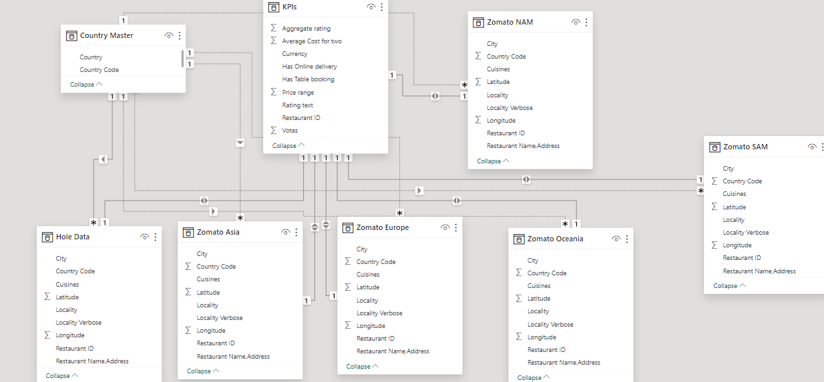

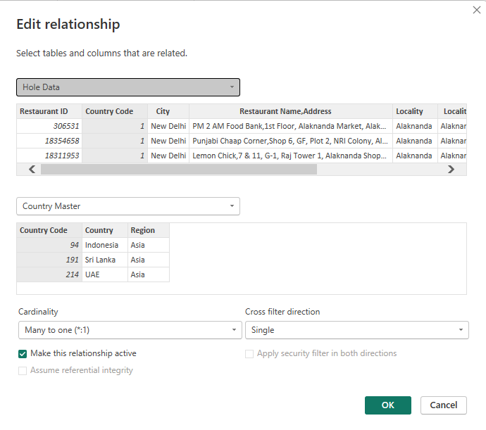

In Power BI, editing relationships allows users to adjust how tables are linked together, which is crucial for accurate data analysis. This feature enables users to establish or modify connections between tables based on common fields, ensuring data integrity and enabling seamless querying across multiple tables. By editing relationships, users can define relationships as one-to-one, one-to-many, or many-to-many, depending on the nature of the data. This flexibility empowers users to refine their data models, resolve data inconsistencies, and optimize performance. Overall, editing relationships in Power BI is a fundamental aspect of data modeling, enabling users to create robust and efficient data structures that support their analytical needs.

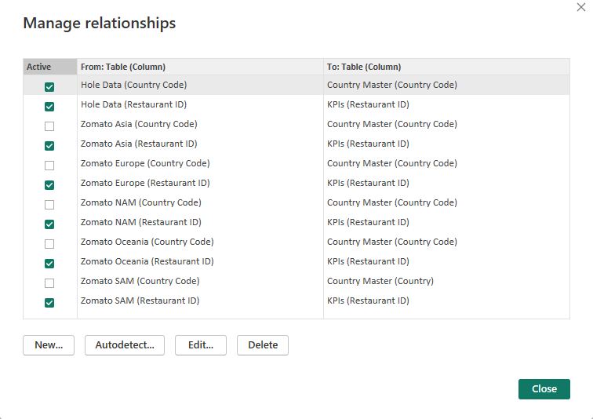

Condition Column:

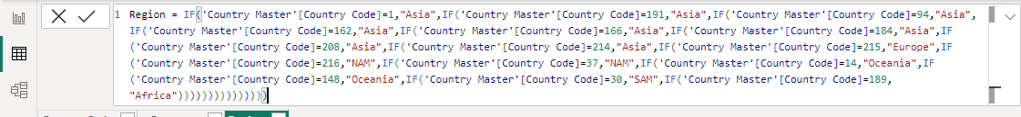

This query is used to connect the another coloums.use this query to split the region from the exiting data.then the data visualization is much better. In Power BI, conditions are utilized extensively to manipulate, filter, and format data. These conditions can be applied in various aspects of Power BI development, such as filtering data displayed in visuals, creating calculated columns based on specific criteria, applying conditional formatting to visuals, defining measures with dynamic logic, transforming data in the Power Query Editor, implementing hierarchical filtering, and parameterizing queries for interactive filtering. Essentially, conditions in Power BI empower users to tailor their data analysis, visualization, and transformation processes to suit their specific needs, enabling them to derive valuable insights and make informed decisions effectively.

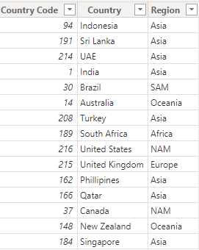

In this data the new column added named Region to identify the country with the help of country code.every contry code have a uniqu region so easy to access the slicer.

* 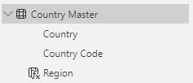

Changing the order of Region name at Power Query

Duplicate the “district /region” then split column using space as delimiter.Then merge column by Region and direction. Refer to applied steps for details.

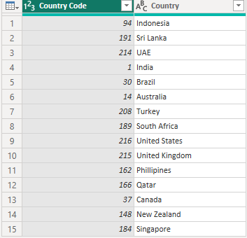

**Edit the columns:**

**In “country master” dataset there are so many duplicate columns. Use the condition columns to remove the duplicate columns and null values**

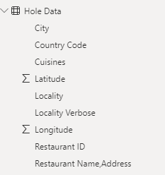

**Combine data set using power query:**

Create a new dataset named “Whole data” and combine all the existing dataset into

One single dataset.it is used to access the visual more effectively .The main dataset

Named as Wholedata .it consist 6 type of dataset named as “Zomato Africa”,

“Zomato asia”,”Zomato europe”,”Zomato oceania”,”zomato NAM”,”Zomato sam”

**Dashboard:**

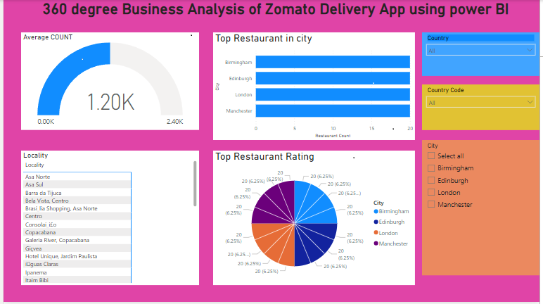

**CONCLUSION**

The project “Real-Time Analysis of Zomato Customers” using PowerBI has successfully demonstrated the potential of data analytics in the Food sector. The real-time analysis of customer data has provided valuable insights into customer behavior, preferences, and trends, thereby facilitating informed decision-making. The interactive dashboards and reports have offered a comprehensive view of customer data, enabling the identification of patterns and correlations. This has not only improved the efficiency of data analysis but also enhanced the zomato ability to provide personalized services to its customers. The project has also highlighted the importance of data visualization in making complex data more understandable and accessible. The use of PowerBI has made it possible to present data in a visually appealing and easy-to-understand format, thereby aiding in better decision-making.

**FUTURE SCOPE**

In the coming years, Zomato is poised to expand its scope beyond its current offerings, driven by a combination of technological innovation, strategic partnerships, and evolving consumer demands. While continuing to strengthen its core food delivery and restaurant discovery services, Zomato is likely to explore new avenues for growth, including vertical integration into food production and supply chain management. International expansion remains a significant opportunity, with emerging markets presenting untapped potential for the company. Diversification into adjacent sectors such as grocery delivery and alcohol delivery, along with a heightened focus on sustainability and health-conscious options, could further broaden Zomato's appeal. Continued investment in technology, including artificial intelligence and machine learning, will enable Zomato to enhance its platform's capabilities and deliver personalized experiences to users. Strategic partnerships and collaborations with other industry players may unlock synergies and create new revenue streams. Additionally, data monetization efforts leveraging Zomato's rich dataset could provide valuable insights to businesses and advertisers. As Zomato navigates these opportunities and challenges, its ability to innovate and adapt will be pivotal in shaping its future trajectory in the dynamic landscape of food delivery and hospitality services.

**REFERENCES**

<https://youtu.be/ZgzGqoq3Xuc?si=ClRHlJTMjVwfV3VT>

**LINK**

<https://github.com/Muppudathi06/online-delivery-app.git>